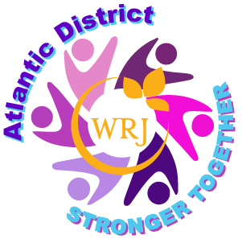

Dear Sisterhood President & Treasurer:

This is not your usual dues request letter. I’m happy to report that some financial relief has been made possible for your sisterhood again this year, WRJ again received a generous grant from an anonymous donor. WRJ Atlantic District dues for this fiscal year 2021-2022 are being covered by these grant funds. Your group does not need to remit the usual $2 per member district dues.

WRJ dues are still payable to WRJ North America and you should have already received an invoice for $18 per member. If you haven’t already sent payment, review your membership numbers and ask your treasurer to promptly pay the dues owed. WRJ dues of $18 per member should be sent to:

WOMEN OF REFORM JUDAISM
633 Third Avenue, New York, NY 10017-6778

This is also an opportunity to send a donation to the Atlantic District Jeanette Miriam Goldberg Youth Fund. The JMG Youth Fund benefits teens within our district through NFTY scholarships that enable attendance at regional and national events. The Atlantic District sends funds to both NFTY PAR and NFTY GER with your support.

Please let us know how many members you have this year and use the form to send a donation if you can support this vital district fund. Send your donation check payment to:

Ellen Mirbach
WRJ Atlantic District Treasurer
6207 Meridian Boulevard, Warrington, PA 18976

The dues information and donation submission form are available on the Atlantic District website “Membership & Dues” page: wrj_atlantic_district_dues_2020-2021.pdf
and is also available on Yammer in the files section of the Atlantic District group:
District Dues 2020-2021 Information & Donation Submission Form

If you have any questions or concerns, please don't hesitate to contact me. I'm happy to assist in any way I can.

L’Shalom

Ellen

Ellen Mirbach
WRJ Atlantic District Treasurer
semirbach@gmail.com or WRJ.AtlanticDistrict@gmail.com

